Concord Community Center
Concord 55+ Social Group
Come join us!

Be a part of the Concord 55+ Social Group at the Concord Community Center. No dues, no obligations, only a fun get-together two times a month! Our fun and informative socials include dessert and are open to all those age 55 and over. Socials are held the first and third Wednesday of each month from 1:30 pm to 3:30 pm at the Concord Community Center unless otherwise noted. Please be sure to call us at (440) 639-4650 to reserve your seat & your treat!

Calendar of Events

September, October, November & December

2017

Concord Township Community Center
7671 Auburn Road, Concord Ohio 44077
(440) 639-4650

September 6th
Cruizin Crooners
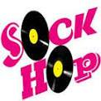
Get ready to party & kick up your heels at this Social Gathering! The CRUIZIN CROONERS will take you on a nostalgic walk back in time with such fabulous sounds of Dion, Elvis, Patsy, Brenda, Martina, Little Eva, George Jones, all mixed with a splash of Country and Dean Martin and so many more that you have to get out on the dance floor! The CRUIZIN CROONERS don't just touch your heart with song, they entertain you and try to make you feel like you are part of US because without YOU there is no US!!!

September 20th
Local Author Tam Polzer

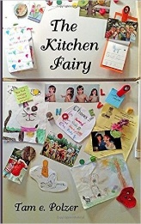
Do you believe in Angels? Author Tam Polzer will share her personal account of meeting her angel in the airport as well as share sections from her novel in which a kitchen fairy and an angel give meaningful advice to a family raising quadruplets named L.O.V.E. (Lilly, Owen, Violet and Ellis). Do you have an angel story to tell? If so, bring it and share with the group for a fun, uplifting afternoon.

October 4th
Medicare Changes

Medicare Open Enrollment starts October 15th and runs through December 7th. This is your opportunity to learn about any changes to Medicare coverage for 2018, and to understand your Medicare options. The presentation will provide an overview of Medicare and the importance of open enrollment.

October 18th
Candidates Forum

Familiarize yourself with the candidates and issues for the
upcoming elections. Listen to short presentations among candidates. Refreshments served afterwards.

November 1st
History of the Morley Library
(& what it can do for you now)

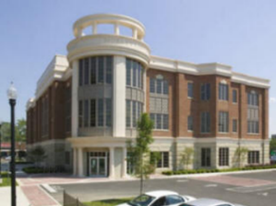
Morley Library in Painesville has been in service for over 100 Years; it opened October 1899 and always continues to grow. Come join us as we revisit the history and all the changes over the years and learn what the library has to offer in these modern times.

November 15th
Mollie Porter / Concord Village Skilled Nursing & Rehabilitation
Paint & Punch

Anyone at any age can Paint! Did you know that painting has so many therapeutic benefits, enhances quality of life and nurtures overall well-being? It can reduce depression and anxiety. Other research demonstrates that the imagination and creativity of older adults can flourish in later life, helping them to realize unique, unlived potentials. Come to our first paint & punch, paint on canvas! We will be serving punch & cookies.

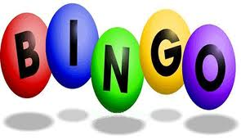
December 6th
B-I-N-G-O

People of all ages have enjoyed playing BINGO! Join the Recreation Staff for an afternoon of fun! Win prizes, snack on desserts, and enjoy the spirit with some friends!

December 20th
Holiday Luncheon

You are cordially invited to join the Recreation Staff at the Concord Community Center to celebrate the holidays together! Come for a special afternoon of Christmas cheer and enjoy a full course meal. The Cruizin Crooners will be here again this year to help us kick off the holiday season in their fun, “Cruizin Style”!

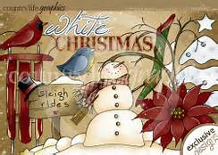
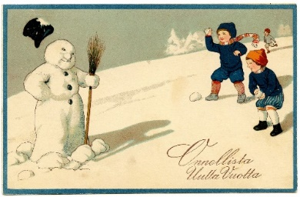
Luncheon starts at NOON
Pre-registration & payment are required by December 6th
Cost for this event will be $12.00 per person.

DO YOU LIKE TO PLAY CARDS?
Join us in the kitchen at the Concord Community Center
for a fun afternoon of cards!

Mahjong – Mondays – 1:00 pm to 4:00 pm
PINOCHLE – Tuesdays – 1:00 pm to 3:30 pm

Interested in other card games?
Please give us a call at the Community Center
440-639-4650

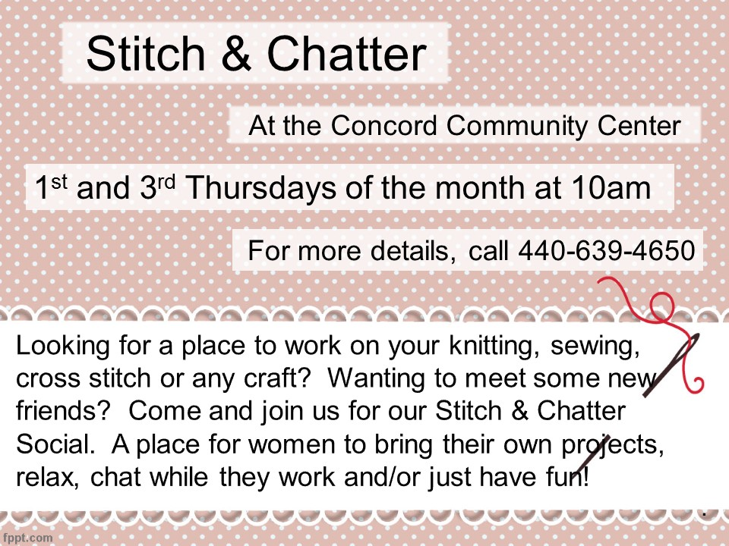

Book Exchange
If you have new or gently used hardback books that you would like to donate to our exchange, please bring them to the Community Center. Stop in and browse through the many titles that are sitting on our shelves, ready to be read.

CONCORD TOWNSHIP COMMUNITY CENTER
7671 Auburn Road, Concord OH 44077
(440) 639-4650
Recreation Director: Debra L. Bechel-Esker
Recreation Administration Assistant: Bonnie Kraska
Recreation Office Assistant: Susie Cobb
Recreation Office Assistant: Star Bruno

