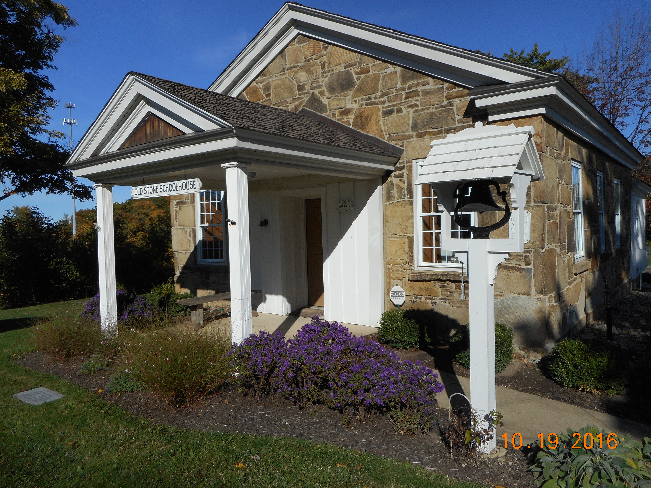

2017 Schoolhouse Calendar of Special Events

January 14 Schoolhouse Snow Shoe Hike 11am

April 29 Schoolhouse Library Book Collection Day 1-3pm

June 10 Schoolhouse Truck Day (ages 4-12) 10am-noon

August 12 Community Days Public Tours 2-4pm

October 24 Ghost Stories Program (adults) 7pm

December 16 Letters to Santa with Mrs. Claus 11am

December 21 Winter Solstice Program & Hike 7pm

* Private Tours available May 1 through November 1 by appointment

